REINFORCEMENT LEARNING

I. Introduction and Core Concepts
1. What is Reinforcement Learning (RL)?
Reinforcement Learning is a subfield of Artificial Intelligence where agents learn on their own by interacting with an environment, without needing external, prior knowledge of the specific problem. The fundamental principle is that the agent optimizes its behavior by gaining numerous experiences.
2. The Agent-Environment Interaction
The interaction between the agent (learner/decision-maker) and the environment is a continuous cycle:
- The agent observes the environment (pulls an Observation).
- The agent processes the observation and takes an Action.
- The environment responds by giving the agent a Reward for its previous action and a new observation.
These cycles can be categorized as episodic tasks (they stop when a condition, like winning a board game, is met) or continuing tasks (they go on forever, like controlling an oil refinery).
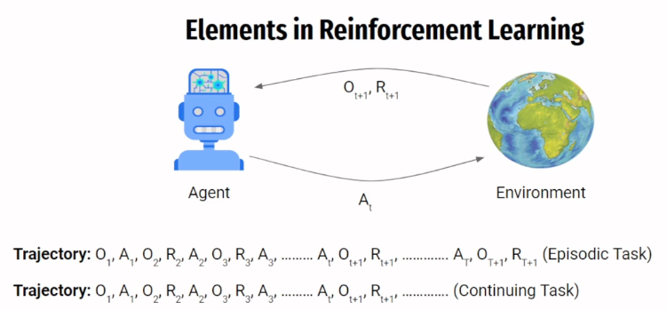
3. Rewards, Return, and Discount Factor
- Reward Signal: This signal defines the goal by indicating what constitutes good or bad events for the agent. Positive rewards can be compared to the release of dopamine in the brain, while negative rewards are analogous to pain.
- Return (G): The agent's ultimate goal is to maximize the total amount of rewards collected, which is termed the return.
- Discount Factor (gamma): This factor limits the agent's ability to look too far into the future when calculating the return, similar to how a player plans three or four steps ahead in chess.
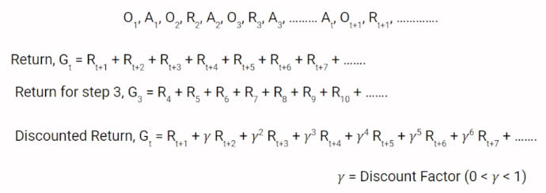
4. Policy and Value Function
Two key functions guide the agent’s behavior and learning:
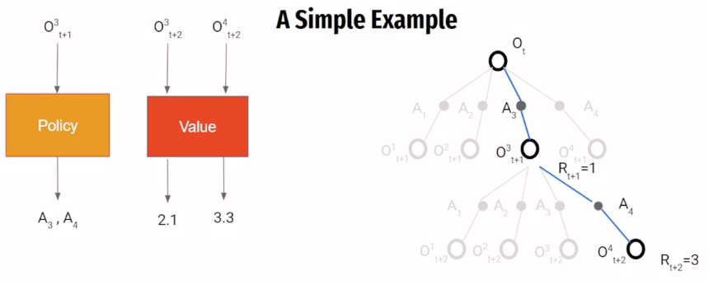
- Policy : This defines the agent's behavior at any given time, acting as a mapping from observed states to the actions the agent should take.
  - A Deterministic Policy throws out a single, concrete action.
  - A Stochastic Policy returns a probability distribution over the possible actions.
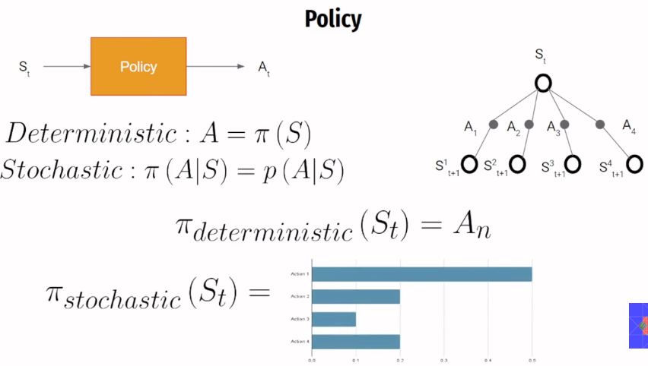
- Value Function (V): This function estimates the expected return that the agent can gain by starting at a certain state and following a specific policy.
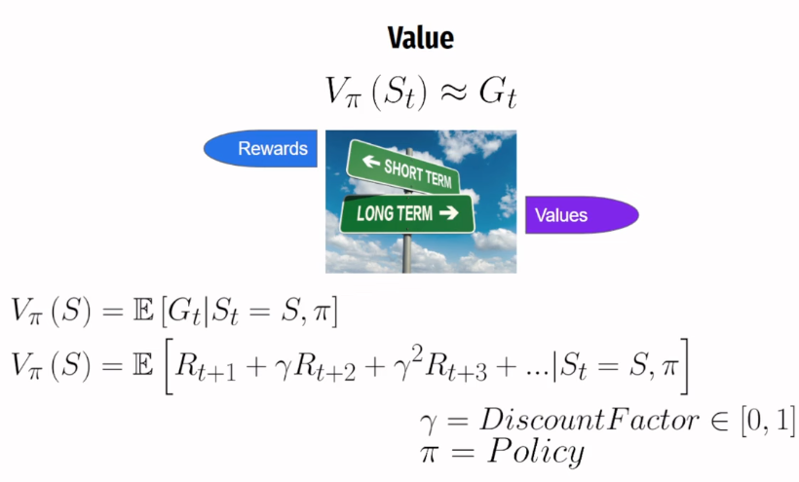
  - While rewards indicate what is good immediately, the value function estimates what is good in the long run.
  - The value function includes an "expectation" because environments are often stochastic (taking one action might lead to several possible next states with various probabilities), meaning the agent must estimate returns based on all possibilities.

5. States vs. Observations and Environment Types
- State: The environment has an internal state that is modified by actions or external factors. The agent must try to estimate this internal state from the observations it receives.
- Fully Observable Environments: Environments where the agent can determine the exact internal state just by looking at the observation (e.g., typical board games like chess).
- Partially Observable Environments: Environments where the agent cannot completely determine the state from the observation (e.g., driving a car, where the agent only sees what its cameras show).
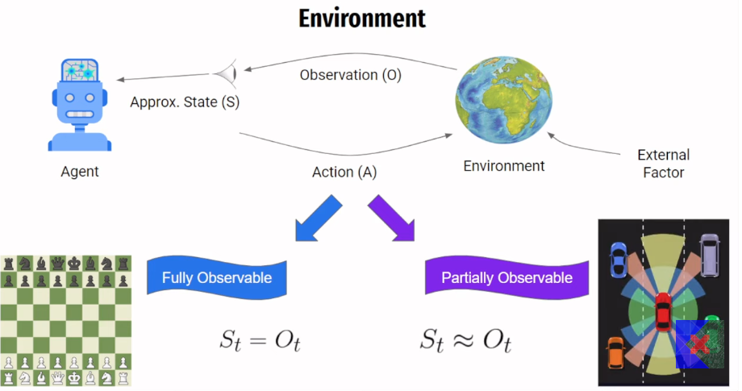

6. 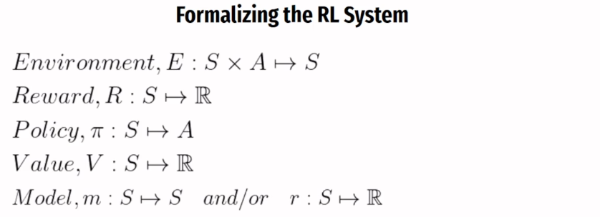

II. Designing the Learning System
1. Markov Decision Processes (MDPs)
The agent-environment interaction is formally called a Markov Decision Process (MDP). MDPs are simplified by the Markov property, which states that the future is independent of the past given the present. This means the probability of seeing the next state and reward depends only on the previous state and action, allowing the full history to be discarded once the preceding state is known.
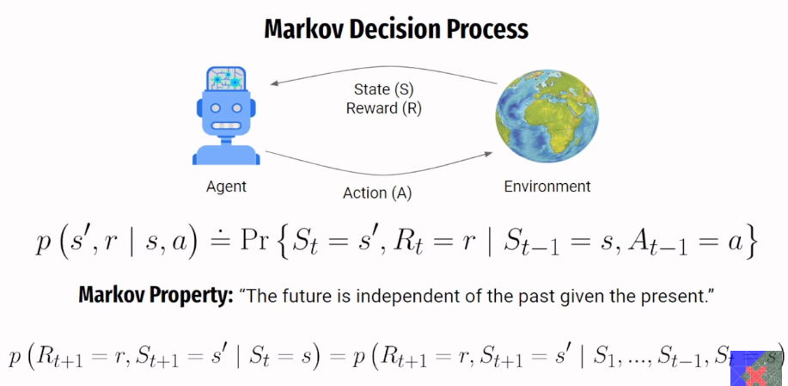
2. Model-Based vs. Model-Free RL
A Model simulates the environment, predicting the next state and reward for a given state and action.
- Model-Based RL: Methods that use a model to simulate experiences and plan the agent's trajectory.
- Model-Free RL: Methods used when the environment is too complex to simulate or a model is unavailable. These agents must rely on learning action values directly from experience.
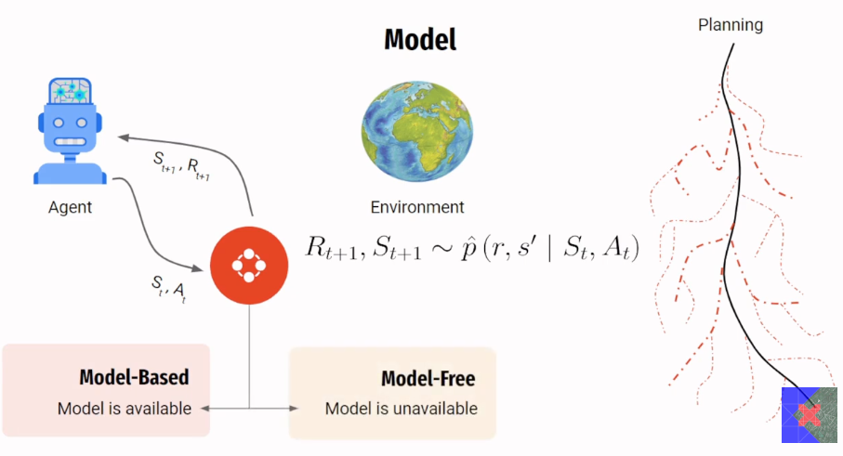
2. State Value Function vs. Action Value Function
- State Value Function ($V(s)$): Calculates the estimated value for a particular state. This is primarily useful in model-based settings.
- Action Value Function ($Q(s, a)$): A modified value function that takes both a state and an action as input, returning an estimate of the value for taking that specific action in that state. Agents use these values to select the action with the maximum value. This function is widely used in model-free settings and forms the basis for algorithms like Q-learning.
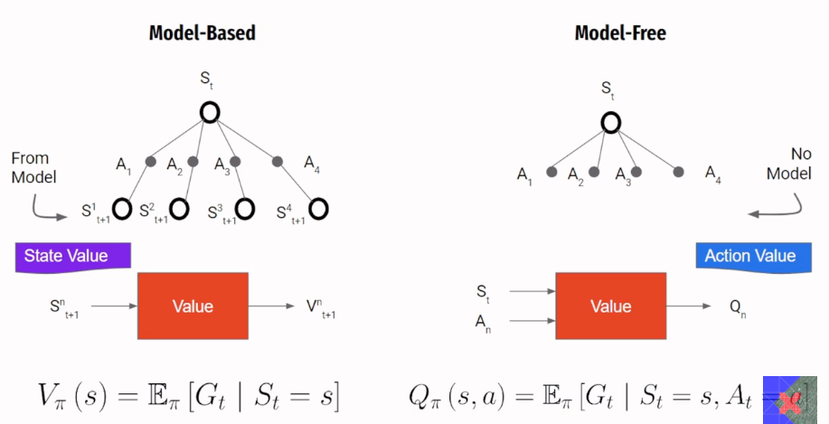
3. The Exploration-Exploitation Dilemma
This is the problem of deciding when an agent should explore new, potentially beneficial actions, and when it sh ould exploit the knowledge it has already learned to maximize rewards.
- The simplest solution is Epsilon-Greedy Action Selection: The agent selects the action with the highest action value (greedy selection) most of the time, but with a small probability ($\epsilon$), it selects an action randomly to explore. During training, $\epsilon$ is often reduced (decayed) over time to favor exploitation.
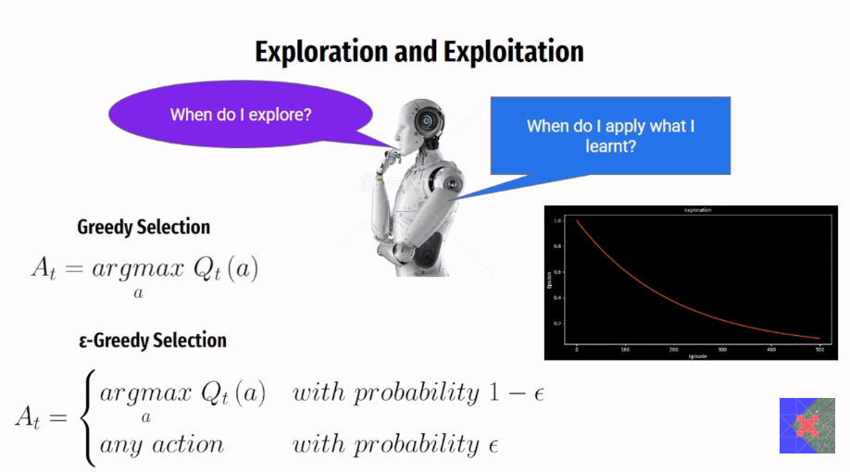
III. Classes of Learning Methods
Learning algorithms have evolved to handle different challenges (e.g., large state spaces or lack of a model).
1. Dynamic Programming (DP)
DP methods calculate state values for a given policy by cycling through two steps, assuming a model of the environment is available:
- Policy Evaluation (Prediction Problem): Calculating the values for all states for the current policy (pi).
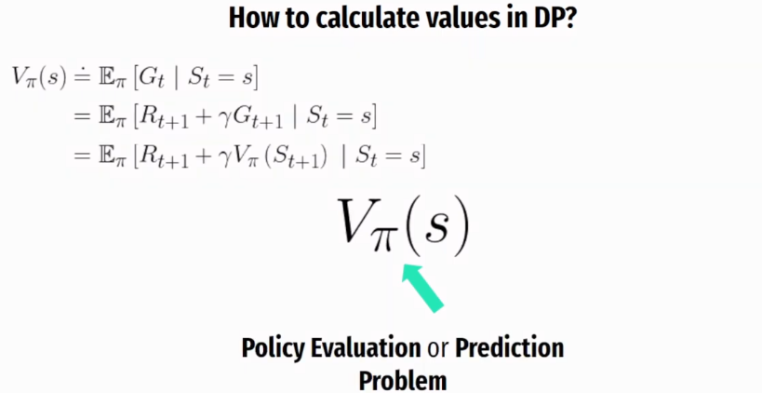
- Policy Improvement (Control Problem): Using the calculated values to improve the policy by taking a greedy step (selecting actions that lead to higher values).
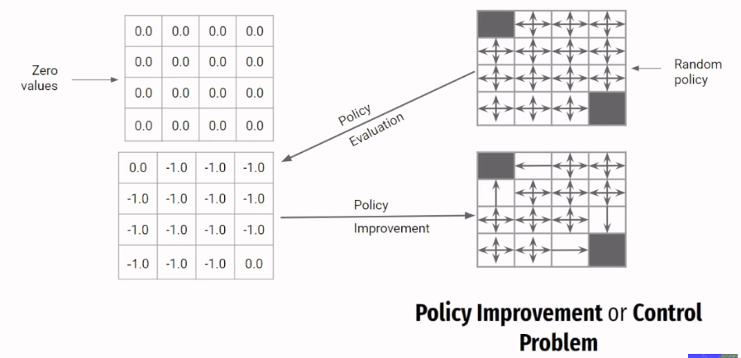
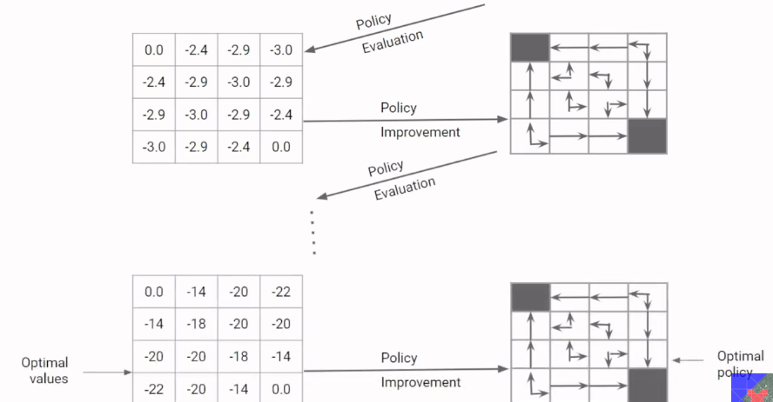
This cycle is called Policy Iteration, finally reaching an optimal policy and optimal value function after sufficient number of iterations.
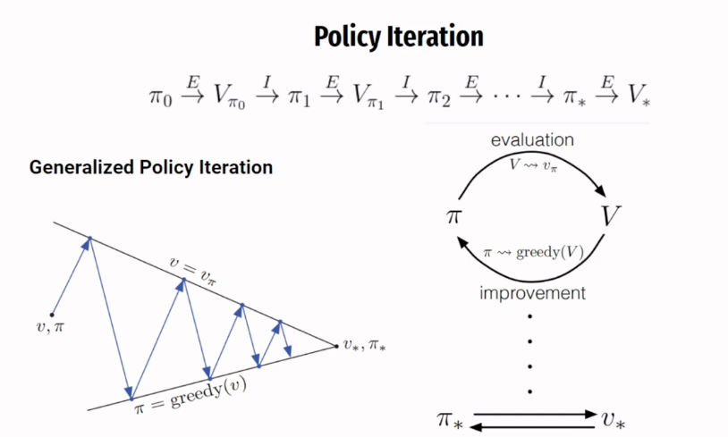
- Limitations: DP requires a model of the environment and assumes complete knowledge. It is also computationally intensive and infeasible for problems with large state spaces (e.g., chess) because it must calculate values for every possible state.

2. Monte Carlo (MC) Methods
MC methods overcome DP limitations by not requiring a model or complete environmental knowledge; they learn solely from sampling actual experienced trajectories (episodes).
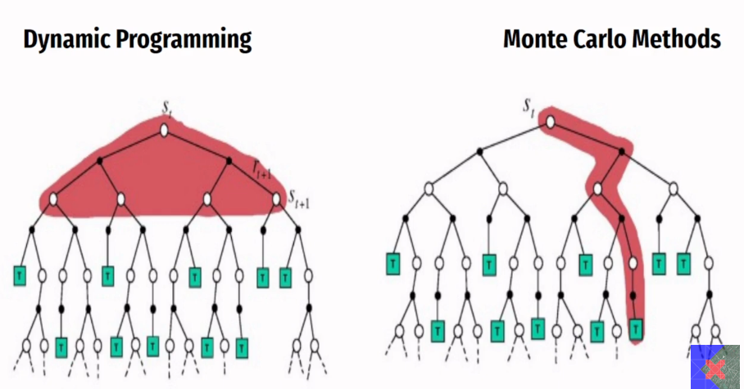
- MC Policy Evaluation: Instead of calculating expected returns (like DP), MC methods calculate values using the sample returns obtained from an episode.
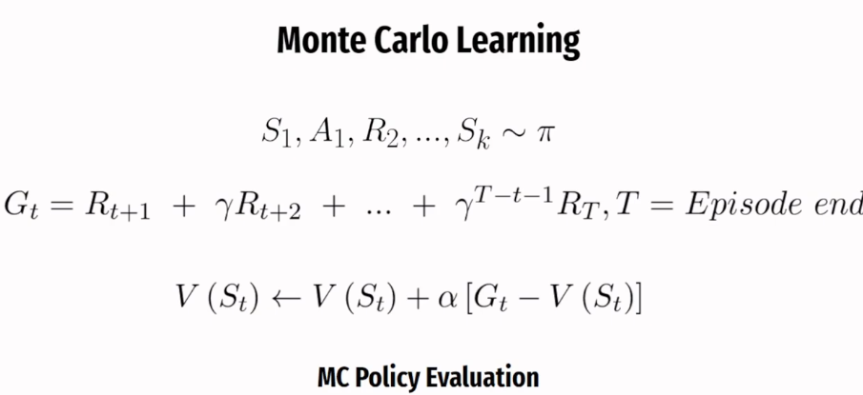
- Limitation: MC methods wait until the end of the episode to perform any learning updates. For long episodes, this makes the learning process very slow. MC methods are considered offline learning.
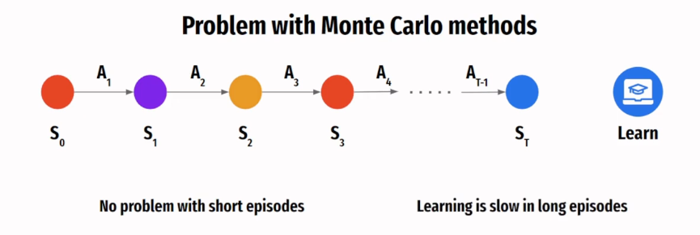
3. Temporal Difference (TD) Methods
TD methods are one of the central ideas in RL, combining aspects of DP and MC.
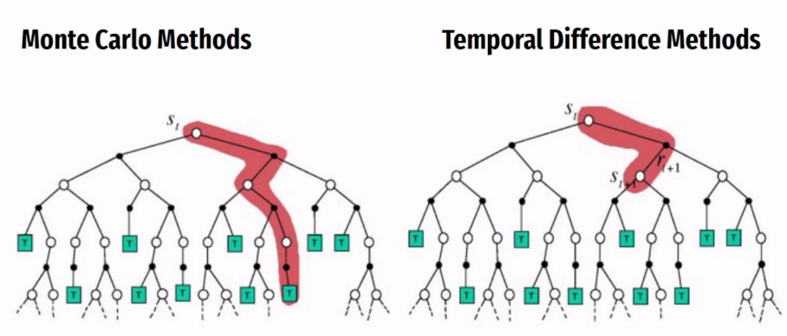
- Online Learning: TD methods are "truly online" because they perform one-step updates immediately after a single transition, rather than waiting for the episode to complete.
- Bootstrapping: TD methods use values calculated from the next state and the reward to create a one-step target, instead of waiting for the actual returns. This relies on the assumption that the prediction at the next step is generally a better prediction than the current one.
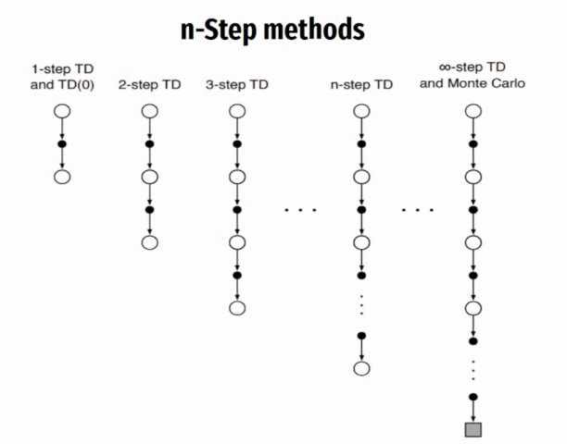
IV. TD Control Algorithms
TD control methods are used for learning optimal action-value functions ($Q$) without a model.
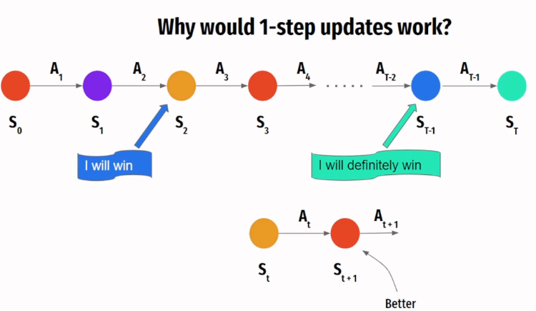
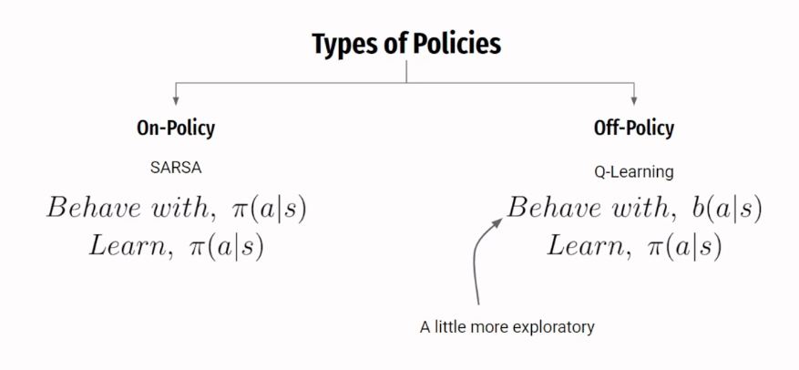1. SARSA (State-Action-Reward-State-Action)
- Policy Type: On-Policy.
- How it Learns: SARSA attempts to evaluate and improve the same policy that is used to generate the agent's actions (e.g., an epsilon-greedy policy). It learns values for a policy that is near-optimal but still exploratory.
- Update Mechanism: The learning update uses the action value of the state-action pair the agent is actually planning to take next.
- Outcome: When applied to problems like the Cliff Walk, SARSA tends to find a safer path because it accounts for the potential low rewards incurred during exploration steps.
2. Q-Learning
- Policy Type: Off-Policy.
- How it Learns: Q-learning learns the optimal policy (target policy) while generating behavior using a different, often more exploratory, behavior policy (e.g., epsilon-greedy). Off-policy algorithms are considered more powerful because they quickly find optimal policies.
- Update Mechanism: The update uses the action value corresponding to the optimal action (the maximum Q-value) at the next state, regardless of the action the agent actually chose to take next.
- Outcome: In the Cliff Walk problem, Q-learning finds the optimal path (shortest distance, even if it runs dangerously close to the cliff).

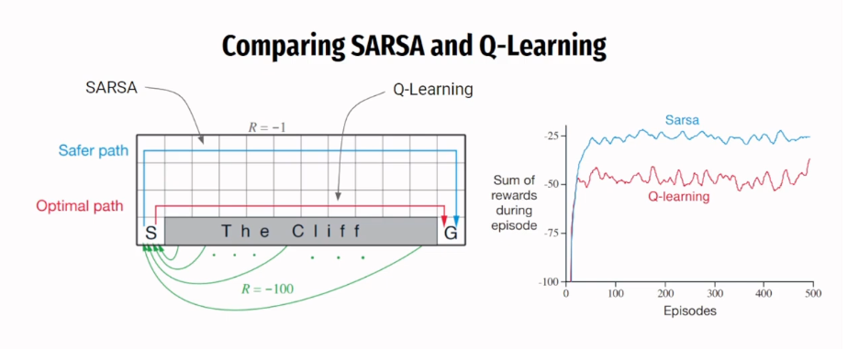

NEURAL NETWORKS INTO REINFORCEMENT LEARNING (RL)
I. The Necessity of Function Approximation
Historically, Reinforcement Learning (RL) stored the policy and value functions using simple tables. However, this tabular approach has severe limitations:
- Scaling Issues: Tables do not scale effectively to problems with large state spaces.
- Continuous Spaces: They cannot handle environments with continuous state spaces (where the number of possible states is infinite).
- Lack of Generalization: Tables do not generalize knowledge between similar states. If the agent encounters a state it hasn't seen before, it has no basis for action.
A more contemporary approach uses Neural Networks (NNs) because they have demonstrated the ability to learn highly complex behavior.
Function Approximators (FAs)
A function approximator is a parameterized function that attempts to estimate an actual function.
- An approximate value function can be represented as V(s,w), where w represents the parameters (weights and biases) of the function,.
- You can think of v(s, w) as the neural network itself, and w as its weights and biases. This network attempts to approximate the true value function.
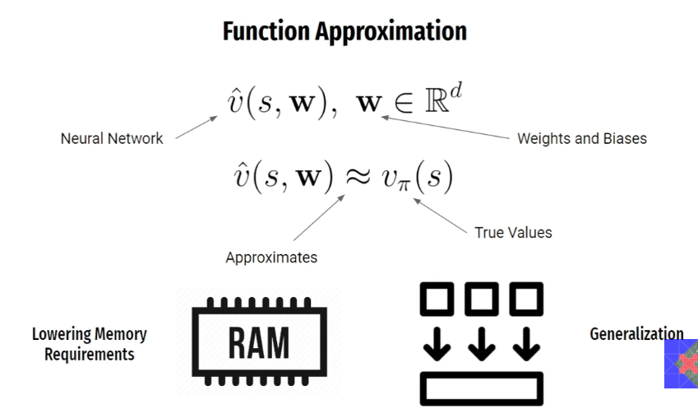
Key Advantages of Using NNs/FAs
- Lower Memory Requirements: Instead of storing every entry in a massive table, FAs require storing only the parameters (w) of the approximated function.
- Generalization: FAs can generalize knowledge to similar states. When a single state's value is updated, that change propagates to affect the values of many other similar states, making the learning process more powerful.
II. Training Mechanism: Gradient Descent and Loss Minimization
Neural networks are trained using supervised learning techniques, which are highly capable methods. The core concept underpinning this training is the gradient.
Understanding the Gradient
- The slope describes the steepness of a line in two dimensions.
- The gradient is the term for the slope in higher dimensions. It gives the direction of steepest ascent. Moving in the direction indicated by the gradient increases the value of the surface.
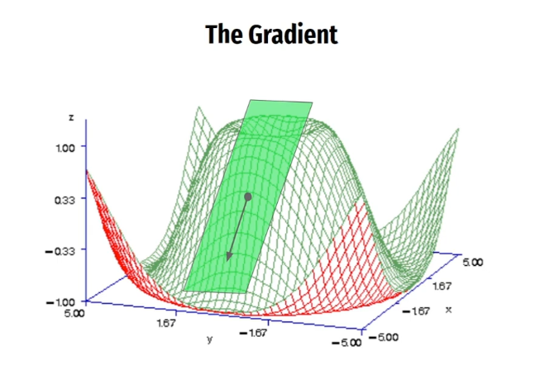
Stochastic Gradient Descent (SGD)
In RL, the goal is often to minimize a loss function, which can be modelled as a "loss surface".
- We define a loss function (e.g., Mean Squared Error between the true values and the approximate values).
- We use the gradients to minimize this loss. Since the gradient points in the direction of steepest ascent, we take steps in the reverse direction of the gradient to move toward a minimum.
- The parameter updates are balanced using a learning rate (alpha).

DEEP LEARNING IN REINFORCEMENT LEARNING (DQN)
I. The Deep Learning Solution: Why Neural Networks (NNs)?
The challenge of classical RL algorithms (like SARSA and Q-Learning discussed previously) was that they required a simple, tabular structure to store action values (Q-values) for every state. This approach failed when the problem involved large or continuous state spaces.
- NNs as Function Approximators: Neural Networks are utilized as function approximators to estimate the complex Q-function. Instead of storing a value for every possible state in a table, the network learns the underlying relationship between states and optimal actions by storing only a set of internal parameters (weights and biases).
- Generalization: NNs allow the agent to generalize knowledge from one observed state to similar, unseen states, making learning powerful and scalable.
- The Shift to DQL: DQN was introduced in 2013 to solve Atari 2600 games by taking raw pixel values as input and learning how to play, which fundamentally changed the perception of RL.
II. Deep Q-Learning (DQL): Key Stabilization Mechanisms
Successfully integrating NNs into RL is difficult because NNs require a stable, static dataset for training (like in supervised learning).
A. Experience Replay (or Replay Buffer)
The Replay Buffer is a biologically motivated memory component that stores past experiences, allowing the agent to "rethink" past decisions.
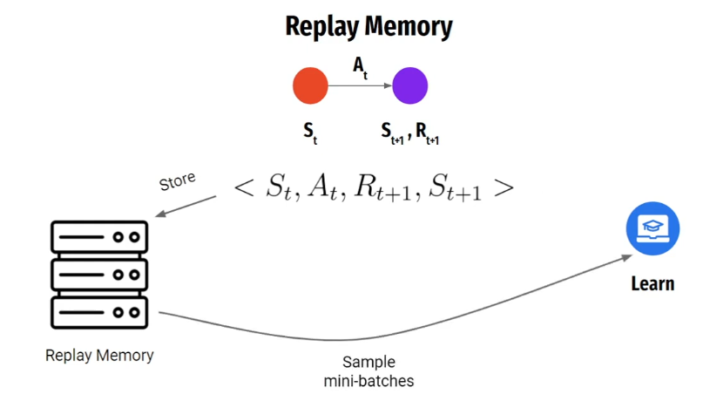
- Function: The agent stores every transition into the buffer instead of immediately learning from it,.
- Learning Step: When an update is performed, the agent samples a mini-batch of transitions randomly from the buffer
- Problem Solving:
  - Breaks Correlation: Randomly sampling breaks the strong correlations between consecutive samples generated during online play, which previously caused high variance and instability.
  - Increases Efficiency: Transitions can be reused multiple times for updates, increasing data efficiency.
  - Necessity for Off-Policy: Because the agent is learning from data generated by past policies (which might be very different from the current policy), DQL must use an off-policy algorithm like Q-Learning over SARSA.
B. Target Network
The Target Network is a second neural network introduced to provide a stable, unchanging target for the weight updates.
- Network Setup: Two networks are maintained:
  - Online Network : The main network, parameterized by weights. This network is used to select actions and is updated frequently.
  - Target Network : A slow copy of the Online Network, parameterized by weights.
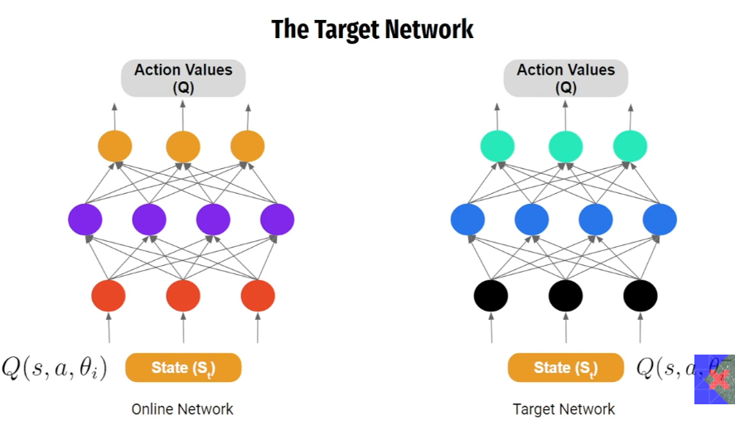

REWARD FUNCTION
A good reward function is defined as one that specifically helps the agent learn the optimal behavior required to solve a particular task.
Sparse vs. Dense Rewards
1. Sparse Rewards
Sparse rewards are those that rarely give useful feedback to the agent, leading to very slow learning.
- If the agent receives a reward of zero for every step and only a positive reward (+1) upon reaching the goal state, it receives no information about whether an intermediate state is good or bad, or whether it is near the goal. The agent must rely on random exploration, which becomes exponentially slower as the environment size increases.
  - Limitation: Even this approach does not tell the agent if it is moving near the goal state, meaning the agent gets no feedback about its trajectory until it is very close.
2. Shaped Rewards (Dense Rewards)
Shaped rewards provide continuous, useful feedback throughout the episode, often leading to easier and faster learning, though they are more complex to design.
- In shaped rewards, the reward value increases smoothly as the agent approaches the goal.
- The agent receives feedback at every step, allowing it to immediately infer if it is drifting away from the goal and correct its trajectory.
